Instruction for students on usage of program Adobe Connect Pro 9

1. Computer settings for starting work.
To start working with program, one has to download relevant version of flash-player.
The best browser for work in Connect is Google Chrome.
Then one has to install the file (.exe) and download it http://www.adobe.com/go/Connectsetup
(There is the application for telephone)
https://play.google.com/store/apps/details?id=air.com.adobe.connectpro&hl=ru )
To download on Iphone go to Apple.Store and find Adobe.Connect Application.

2. Schedule.
To enter class, follow link to virtual room that is sent to you with schedule.

3. Access.
If you click on link via schedule, you will see web page (pic 1).
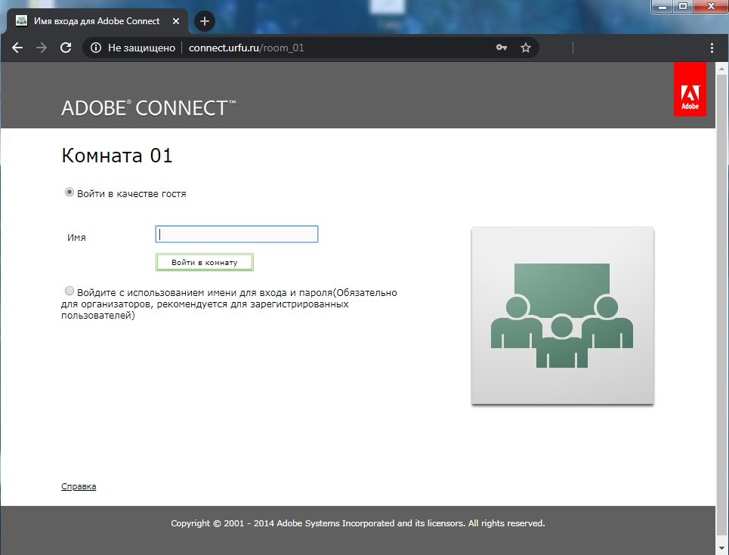
Pic. 1. Home page

In address field, there is “insecure connection” button. Click on it and choose “allow” (pic 2).
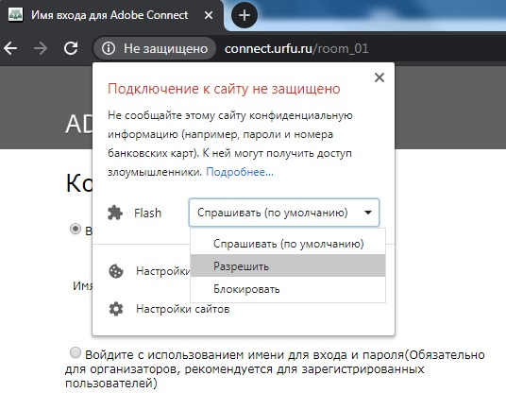
Pic. 2. Insecure connection

If there are no Flash settings to allow access, open “Website settings” (pic 3).
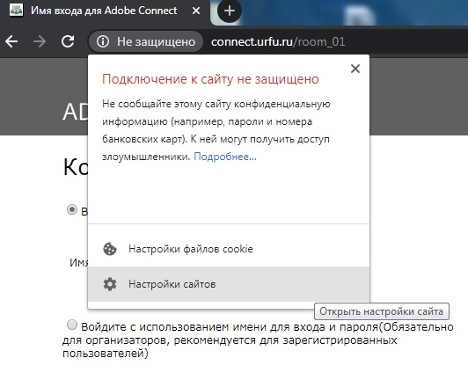
Pic. 3. Open website settings

In section “Allow” find “Flash” and choose “Allow” (pic 4).
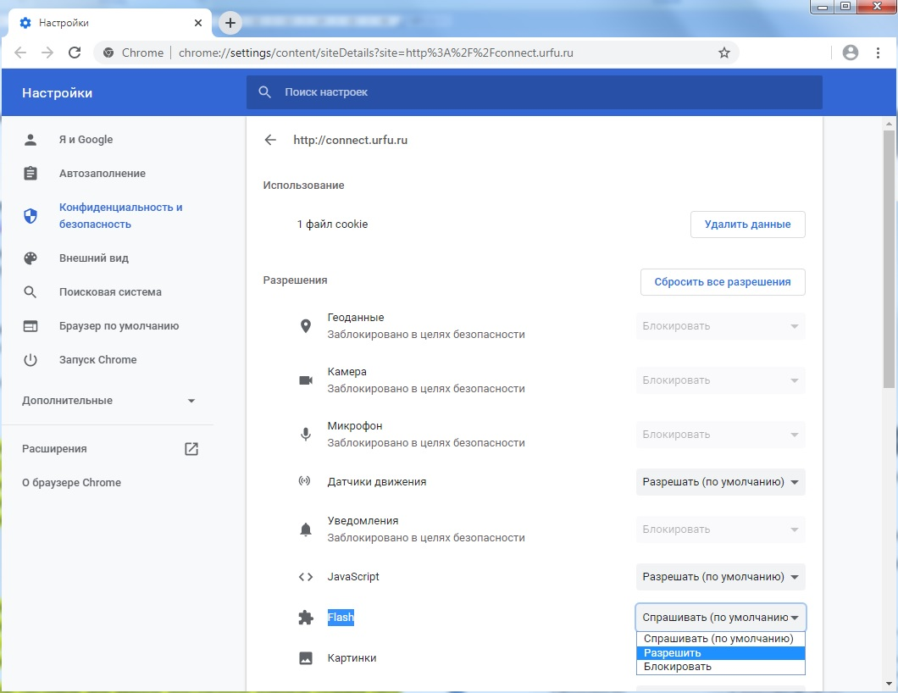
Pic. 4. Allow access
Then either reload the page or open page following the link again in the schedule (pic 5).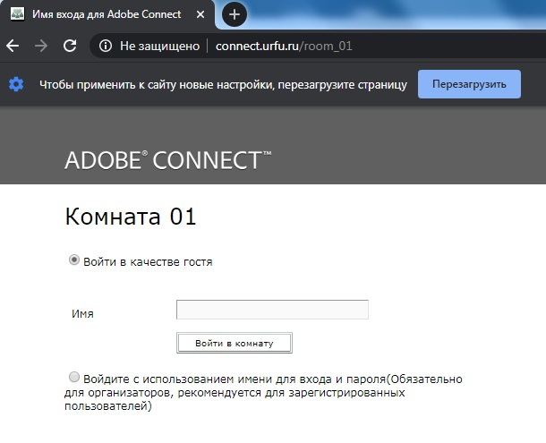
Pic. 5. Reload page
Then choose “Login as a guest”. Type in your Surname and name and click on “Log in Room” (pic 5).
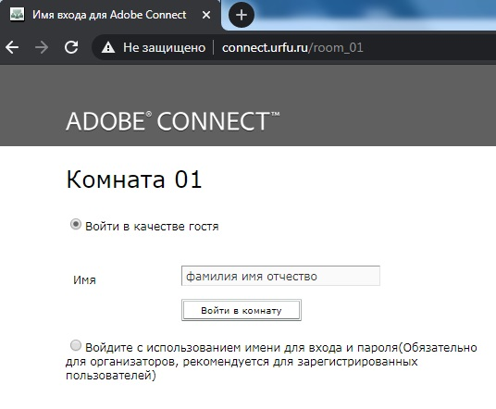
Pic. 5. Type in your Surname and name
If you see popping up message of updating Flash Player (pic 6), you didn’t allow Flash Player full access. Go back to pic 2.

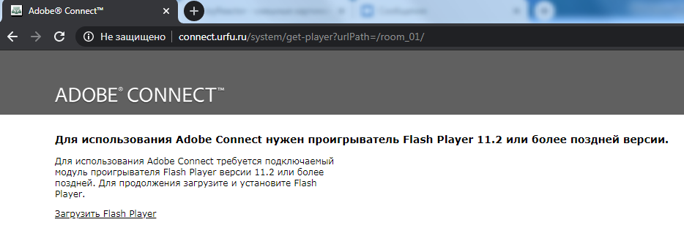
Рис. 6. Do not update Flash Player.

4. The Room.
When you log in as a guest, you only have access to chat (pic 7). 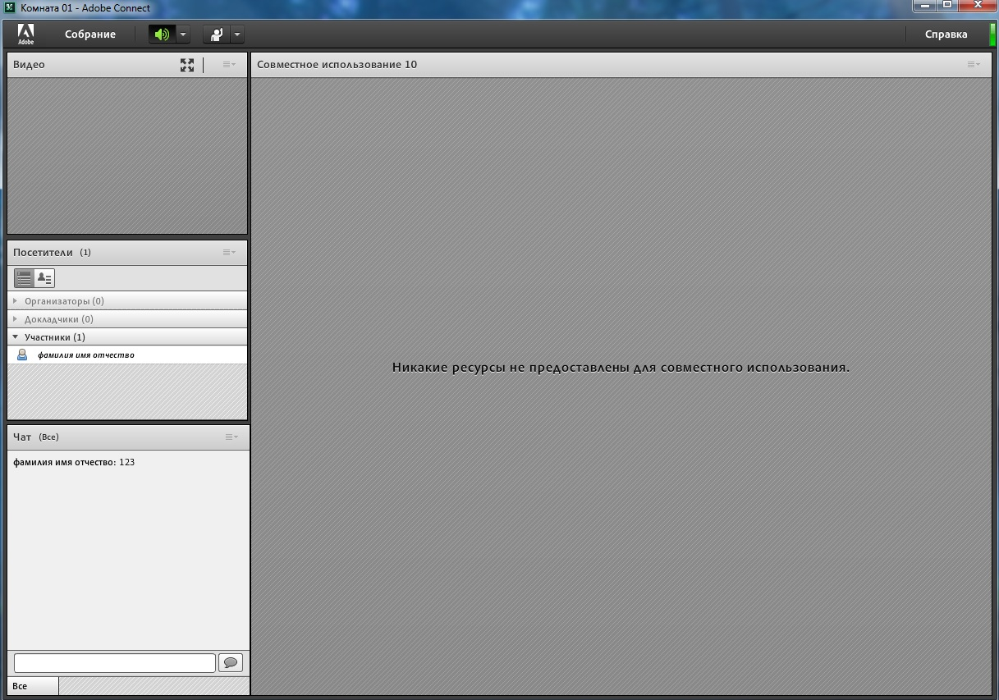
Pic. 7. You are "The Participant"
Professor can make you a Speaker. In this case, you will have access to camera and microphone. You even will be able to upload presentations (pic 8). 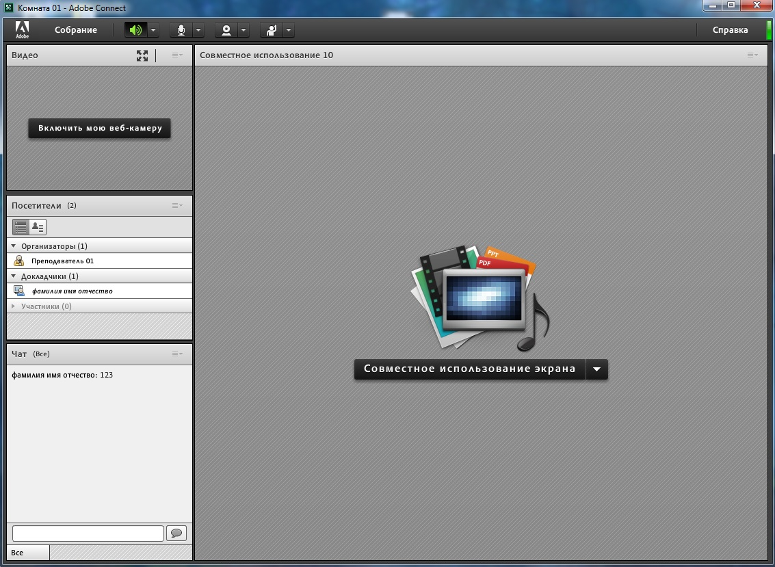
Pic. 8.You are "The Speaker"

5. Presentation.
To upload presentation, click on button , in pop up menu choose “Allow access to document” (pic 9). 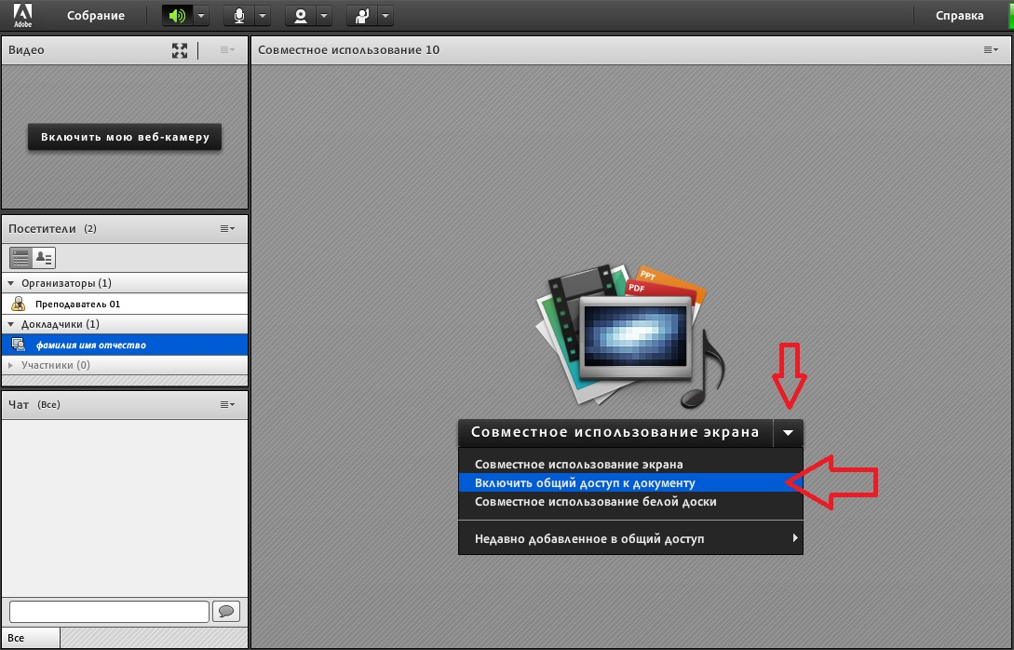
Pic. 9. Menu options
In menu click on “Upload from computer (pic 10). 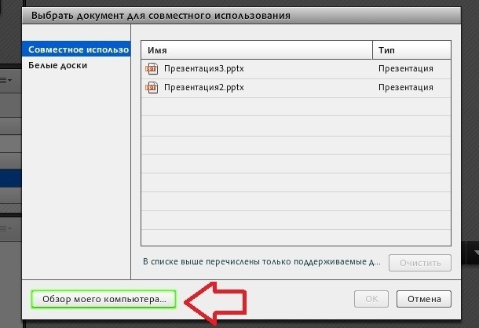
Pic. 10. You may see previously uploaded presentations
In menu, you see files that can be uploaded. Word and Excel files will not be displayed (pic 11).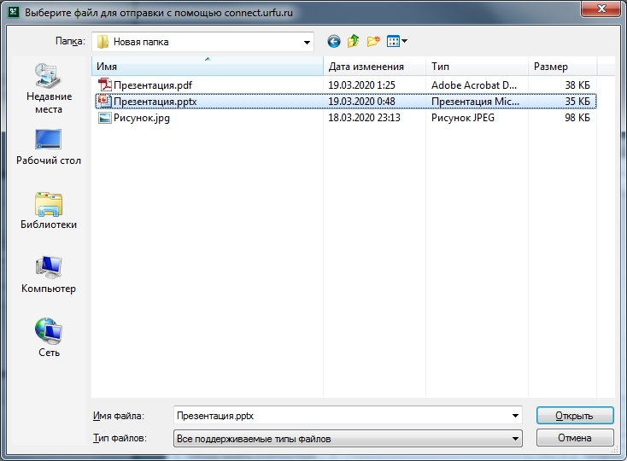
Pic. 11. Upload PowerPoint presentation (files .ppt .ppx)
To stop screen demonstration, click on “Stop share usage” (pic 12).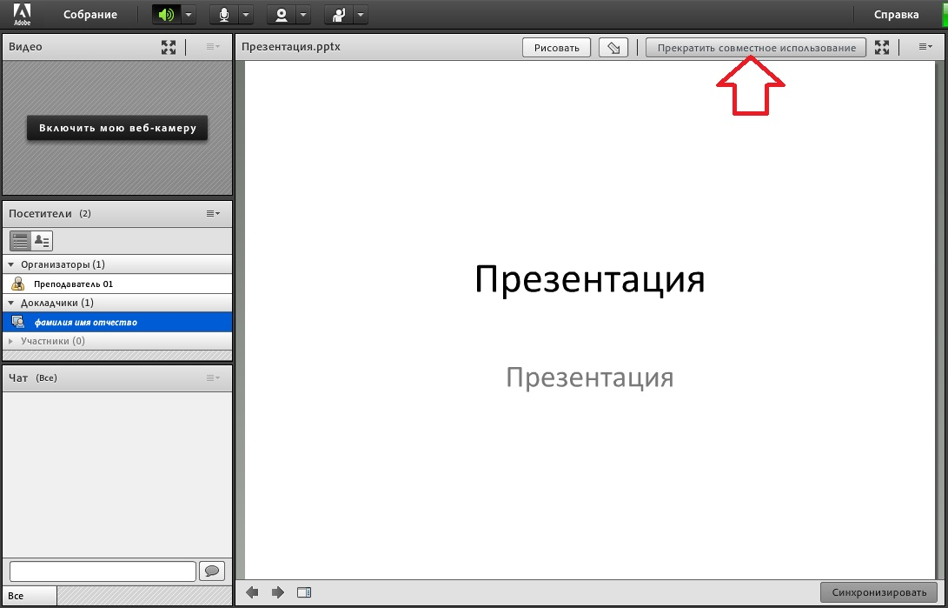
Pic. 12. Stop share usage

