Instruction on subscription to a course
«Attestation of 2nd year aspirants » and «Attestation of 3rd year aspirants »
1. In the address field of your browser (Chrome, Mozilla, Yandex), type in the address of the Urfu e-learning Portal https://elearn.urfu.ru/
2. Then log in to the Portal. Click on “Log in” and type in your student’s personal account details (the same one you use for your personal account).
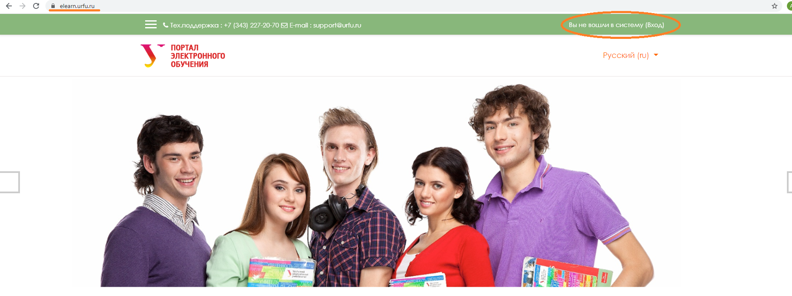

3. On the homepage go to the section “Courses”.
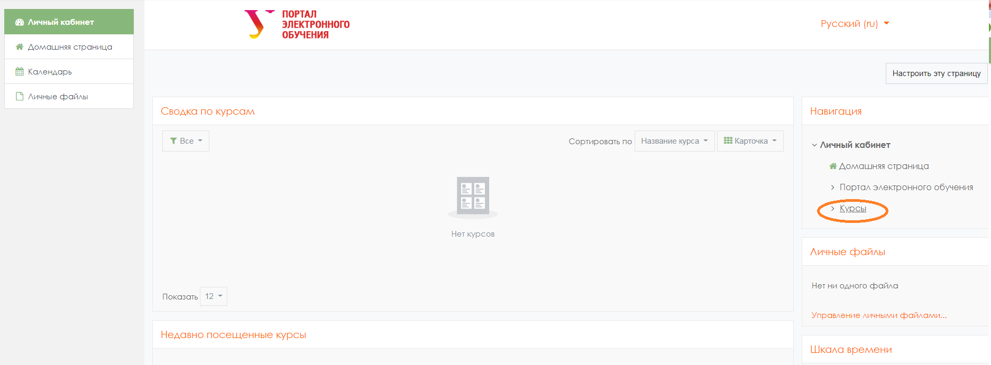

4. Then in the search field type in the name of a course you are going to subscribe to (to specify course name, ask your department or program tutor according to your group).
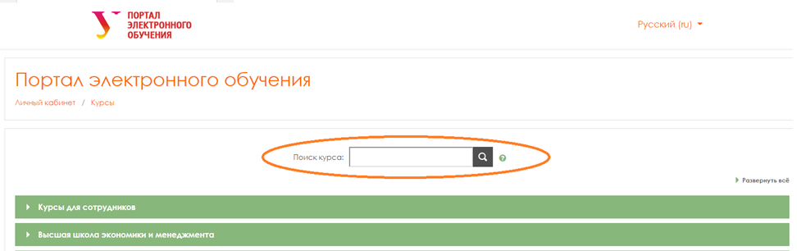
Example:
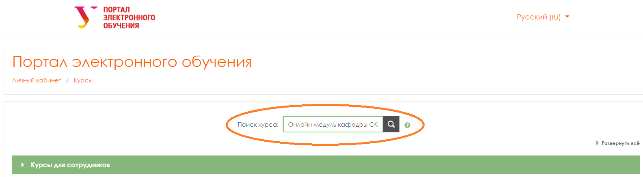

5. On the result page, you will see the course name. Click on it.
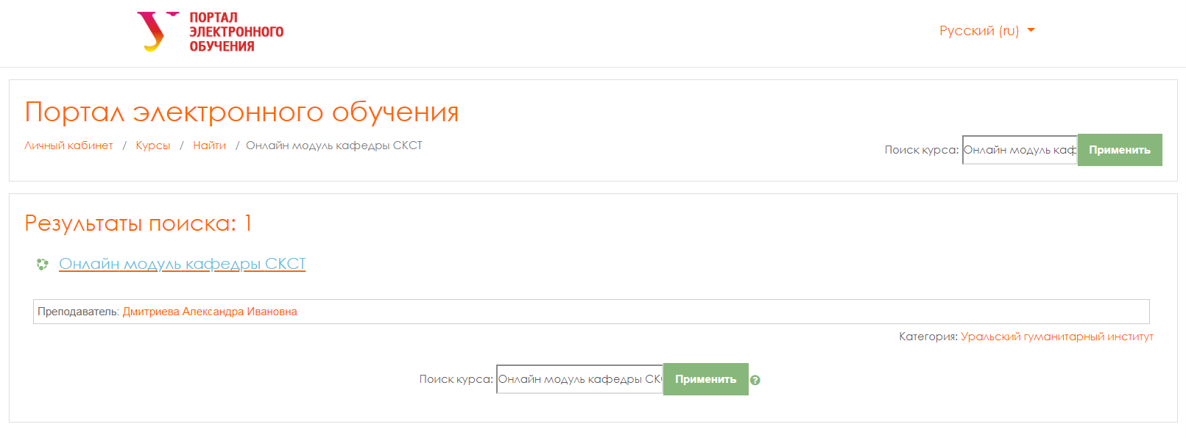

6. On the course homepage click on “Subscribe to a course”.
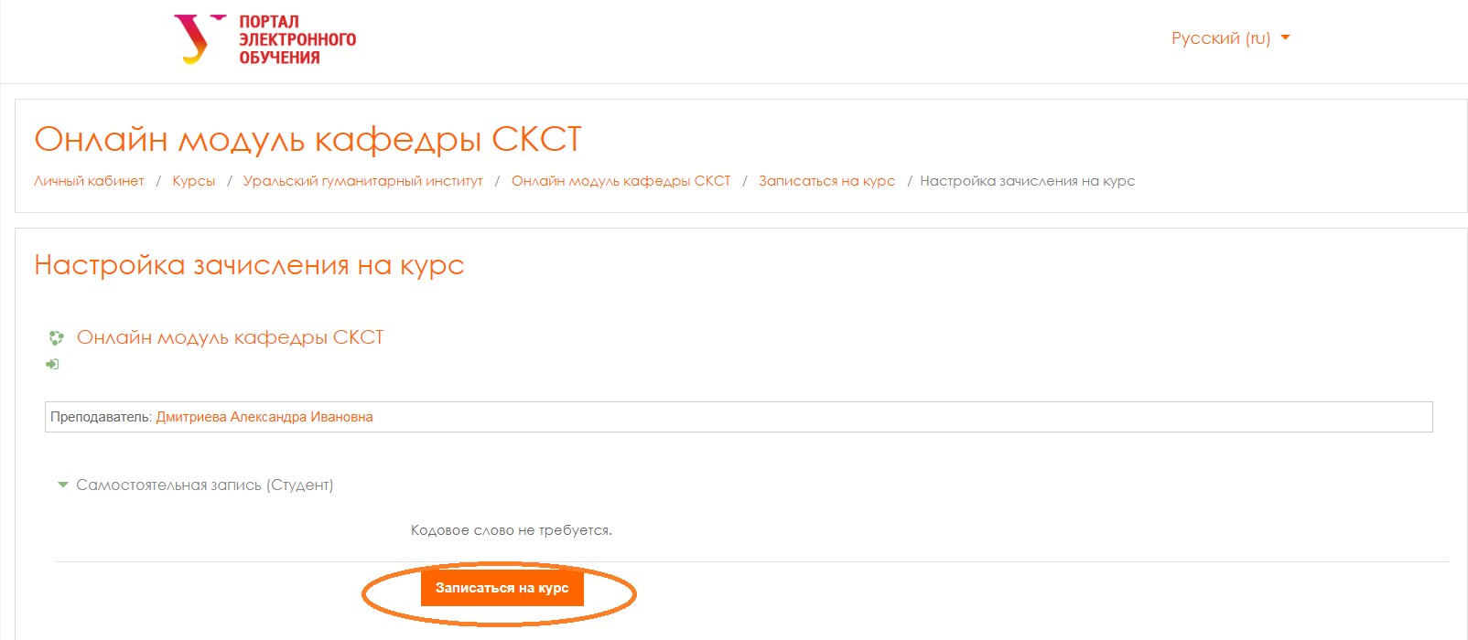
After it, you will see the content of the course. Read the instruction carefully beforehand. Start working with the course.

