Instruction on enrollment to the MOODLE courses:

- “Attestation of the 2nd year aspirants of all institutes_study terms 3 and 4 years (spring 2021)

- “Attestation of the 3rd year aspirants of all institutes_spring 2021_study term 4 years
1. Type in the address of the electronic learning Portal of UrFU into the address bar of the browser (Chrome, Mozilla, Yandex) https://elearn.urfu.ru/
2. Then you have to log in. Click on «Log in» and type in your user name and password which you usually use for a personal account as a postgraduate student.
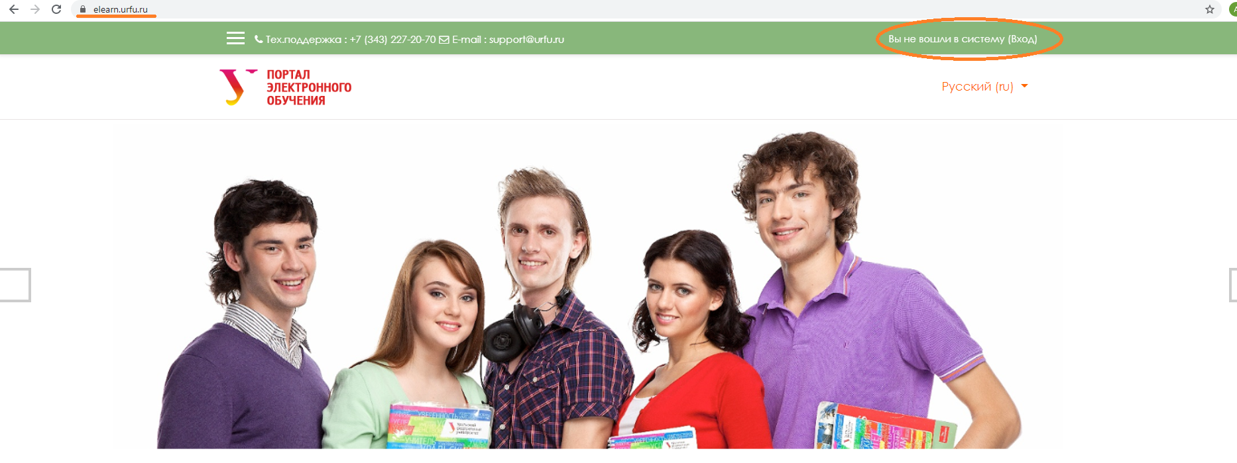
3. Go to “Courses” section on a home page.
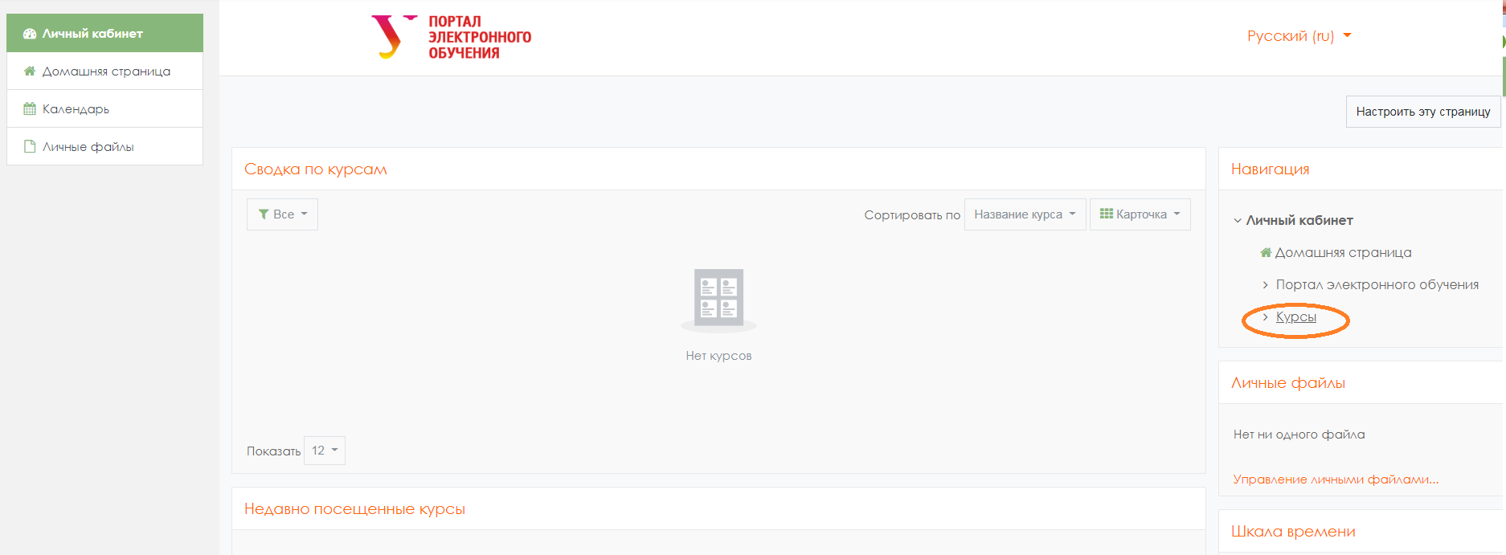

4. Then in the search bar “Course search” type in a name of a course, you want to enroll to (you may get more details on the name of the course at your department or ask the tutor of the program)
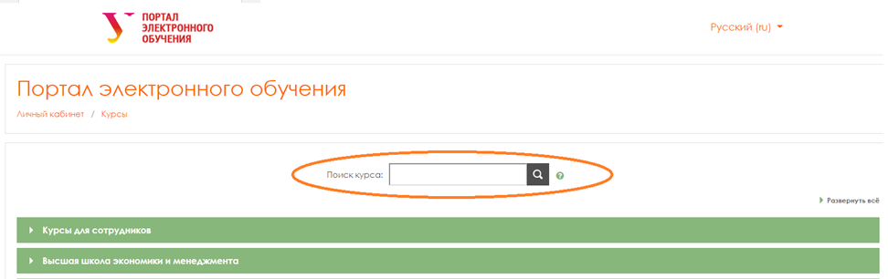
For example,
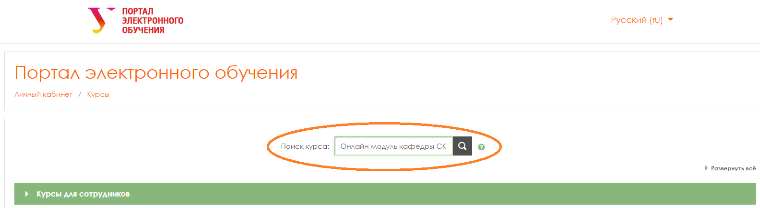

5. You will see the search results page. Click on the course you need.
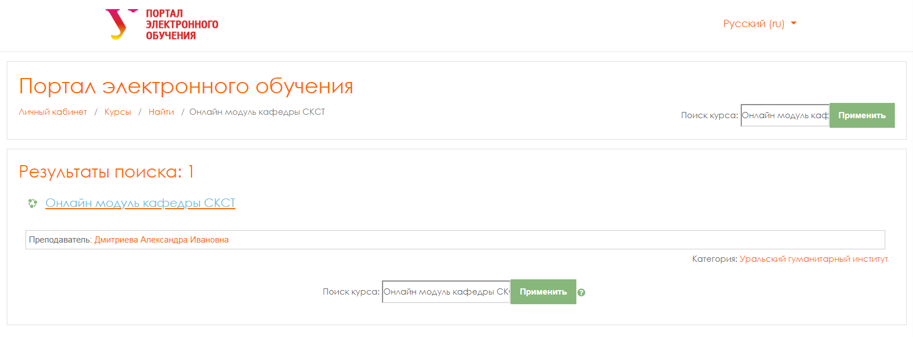

6. On the course home page click on “Enroll to a course”.
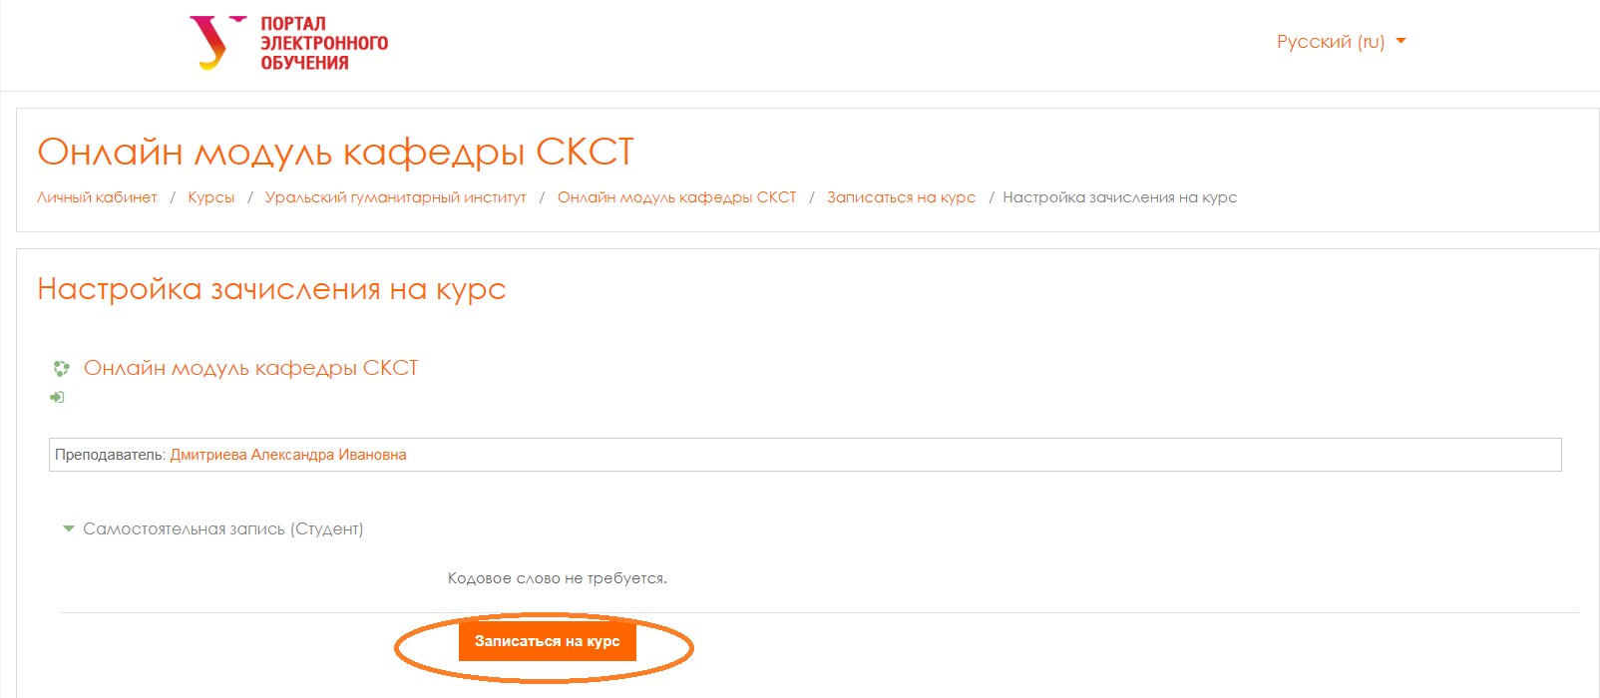
After it, you will get access to the course. Read the instruction for a course carefully and start work. Good luck.

